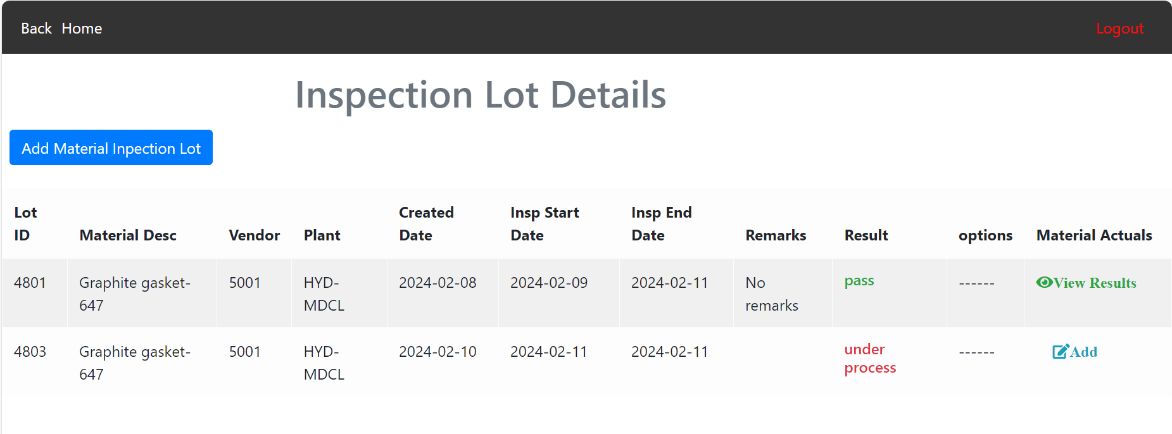

Lot number **4803** is just now added….And for that two I am not showing any options for writing reviews(remarks and result status(pass or fail)). And I am showing add option for Material Actuals. But not showing the option for view results as the added material actuals size is 0.

**There is one error. I should not show Inspection end date.**

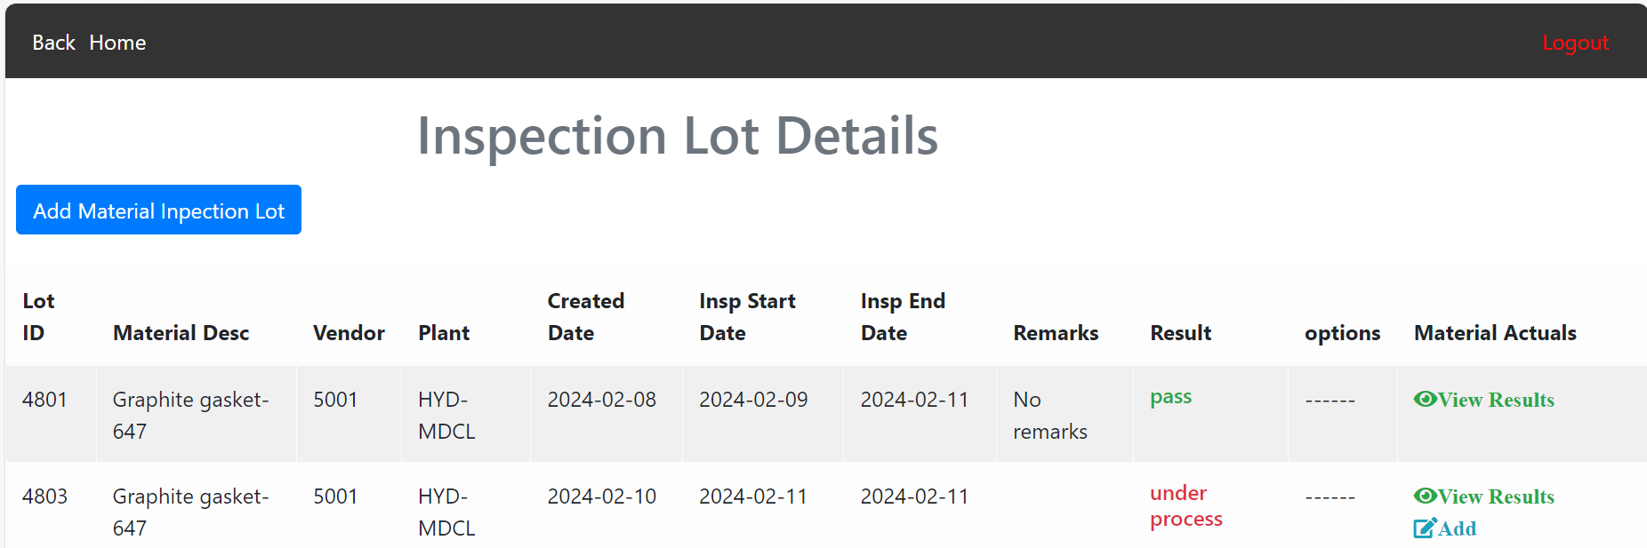

For Lot number **4803** , if I add at least one material actual two options are visible for material actuals view results of material actuals and add material actuals. No options provided for reviews(remarks and result status(pass or fail)).

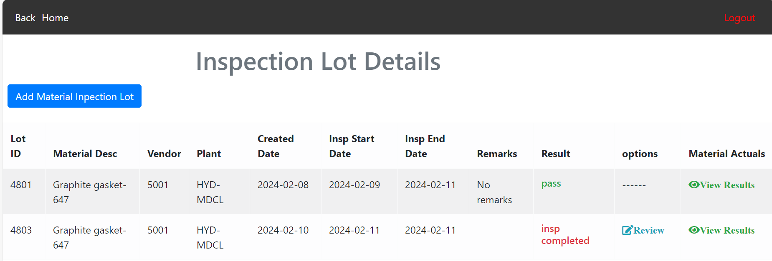

For Lot number **4803** , I have provided all material actuals and the actuals(one or all) does not meet the values of tolerance of upper limit and lower limit of material characteristics. So I am showing the result as **insp completed.** And I provided an option **Review** for updating the result status(pass or fail) and remarks in the below diagram. I forgot to provide color (red for not met values).

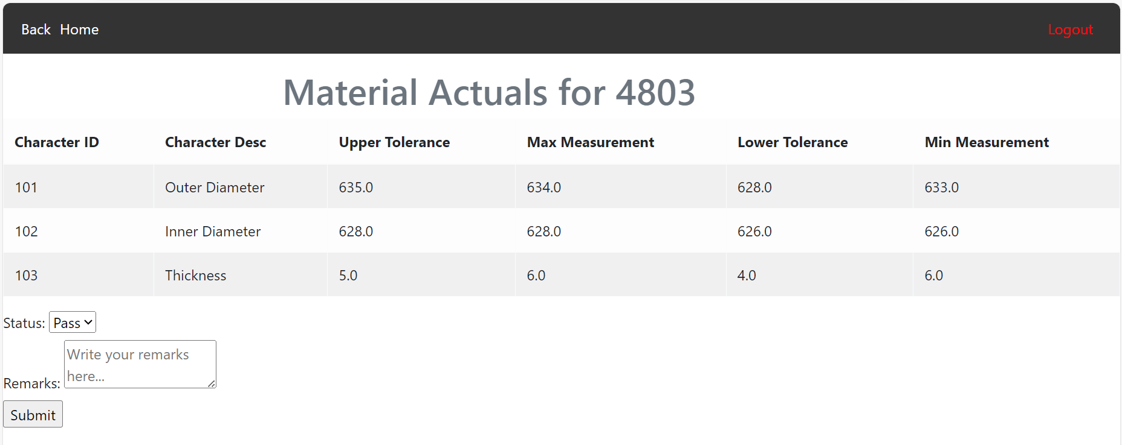

I provide remarks and failed it manually based on my thoughts. And you can understand the options.

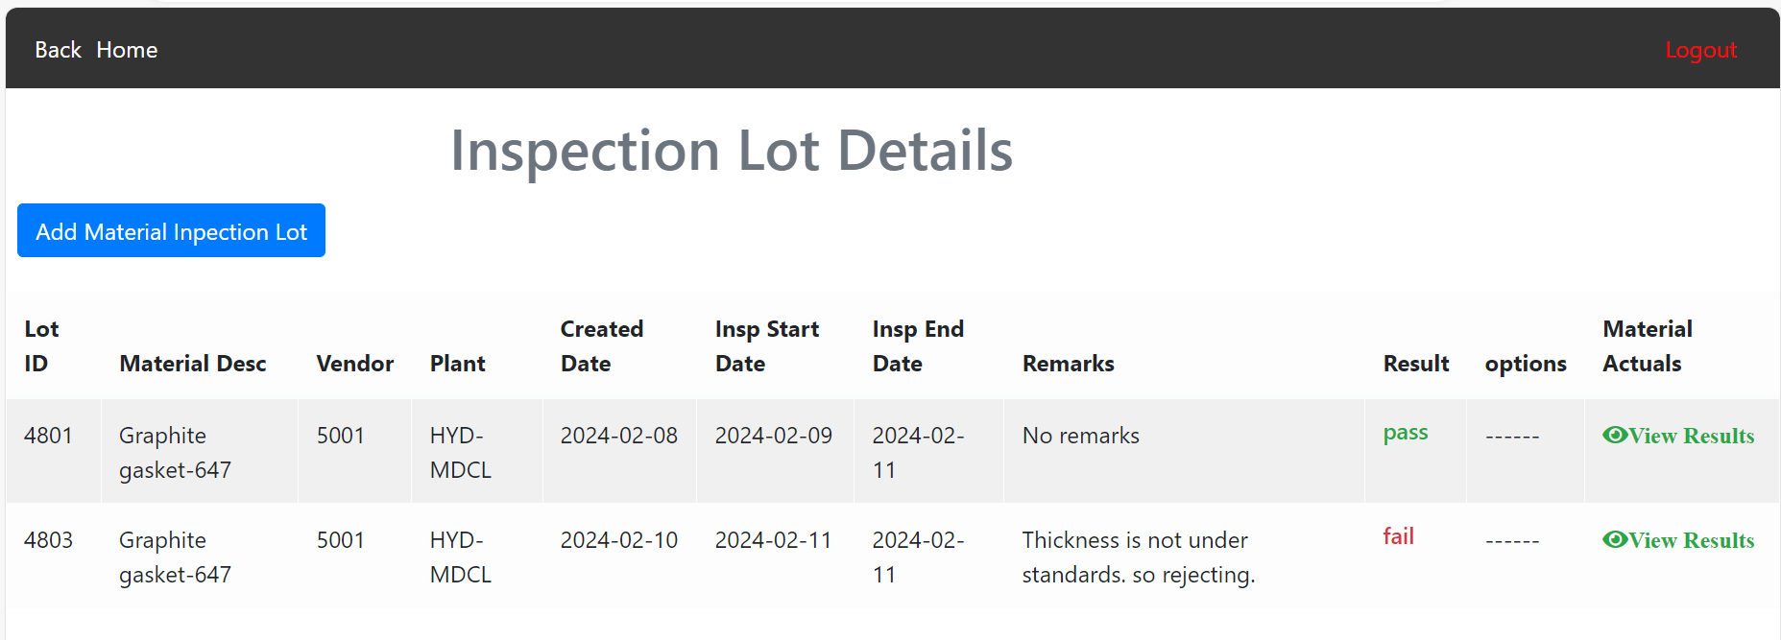

No need to do anything if actuals are under the standards provided when all actuals added. It has to be passed automatically and remarks as no remarks.